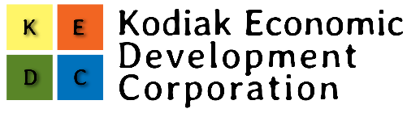

May 28, 2020
The City of Kodiak and the Kodiak Economic Development Corporation announce the creation of the Small Business Emergency Grant Program to support businesses and non profit agencies on Kodiak Island that have been financially impacted by closures, restrictions and mandated responses for the Corona virus.
The recently formed nonprofit Kodiak Economic Development Corporation will administer the grant program using a portion of the CARES Act funding allocated to the City of Kodiak through the State of Alaska. The amount of funds to be made available will be determined at the June 2nd Special Meeting of the Kodiak City Council.
Funds will be available to qualified applicants throughout Kodiak Island. Applicants who have previously received CARES Act funding through the PPP program or EIDL funds will be eligible. Seasonal businesses that have yet to experience direct economic losses are encouraged to apply and show projected losses based on a comparison of previous years revenue.
KEDC will release the application on May 29th and close applications on June 9th. All applications will be reviewed in the blind and awarded on a most qualified basis. It is anticipated that KEDC will award a second round of grant funds in mid-summer as more CARES Act funds are released to the City.
KEDC is an outgrowth of the Kodiak Economic Task Force that was formed at the direction of the Kodiak Emergency Services Council. While the Economic Task Force was intended to provide short term support for businesses and nonprofits during the Covid shutdowns, KEDC will be structured to provide follow on support for businesses as it is fully anticipated that the impacts to Kodiak’s economy of the recent closures will last well into next year and beyond.
KEDC is not affiliated with the Chamber of Commerce or Discover Kodiak, however, its mission is to complement the efforts of both organizations and work towards building a strong, diverse and resilient economy for Kodiak Island.
Applications can be found online at www.kodiakeconomictaskforce.com or picked up outside the Discover Kodiak office at 100 Marine Way, next to the Ferry Terminal.
For more information, contact Sarah Phillips at ………

