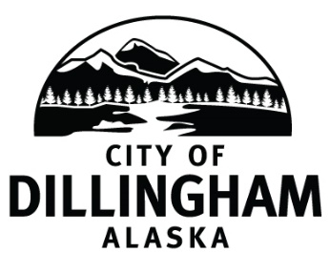

TO: Honorable Representative Neal Foster, Co-Chair, State House Finance Committee
Honorable Jennifer Johnston, Co-Chair, State House Finance Committee
Members of the House Finance Committee

FR: Councilman Andy Anderson

DATE: April 8, 2021

RE City of Dillingham Alaska, Oral Testimony to the State House Finance Committee regarding FY22 state operating budget

Dear Honorable Co-Chairs, and Members, of the State House Finance Committee:

I am Andy Anderson, a member of the City Council of Dillingham, Alaska. Dillingham is the largest city in the Bristol Bay region. It is a regional-hub for 20+ surrounding communities, and it is the heart of the $1 billion annually Bristol Bay red salmon fishing industry – the largest in the world. I testify here today on behalf of the City, the Mayor and the six members of the Council.

Thank you for this opportunity to present the City’s comments on the state FY22 operating budget. Because time is limited, my remarks here will be brief and focus on our highest priorities. The City will submit written testimony later with further information.

Dillingham now faces a “perfect storm” of a critical loss of local government resources due to (i) the continuing erosion of state funding for local government functions and services, (ii) reduced revenues related to Covid-19, such as our bed and sales taxes, and (iii) reduced federal revenues.

We respectfully request that the FY22 operating budget:

- Fully capitalize Community Assistance – FY19 to FY 21 - reduced estimated 37%
- Fully fund School Bond Debt Reimbursement – FY 19 to FY21 = reduced estimated 92%
- Provide additional funding for the Dillingham regional jail, serves Troopers and Dillingham Police Department region-wide – FY20 to FY21 - expenses increased estimated 17%
- Provide additional funding for the Dillingham DMV office – FY20 to FY21 reduced estimated 23%
- Fully fund PCE – power cost equalization
- Hold harmless shared fish taxes, based on the FY19 distribution

Thank you very much for the opportunity to present the City of Dillingham’s testimony on the FY 2022 state operating budget.

