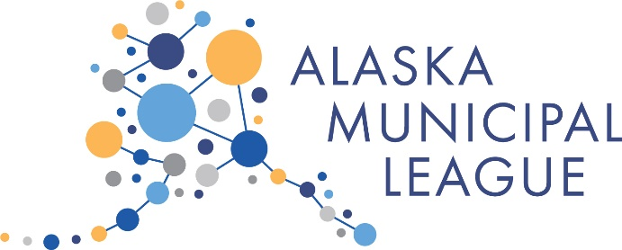

Alaska Municipal League Summer Legislative Conference
Fairbanks, Alaska ~ August 4-6, 2021
Westmark

Wednesday, August 4, 2021 – Concurrent Affiliate Meetings

8:00 a.m. – 5:00 p.m. Alaska Defense Forum

12:00 p.m. – 5:00 p.m. Alaska Municipal Management Association

12:00 p.m. – 5:00 p.m. Alaska Conference of Mayors

12:00 p.m. Welcome and Introductions (Lunch Included)
- Mayor Bryce Ward, President, ACoM

1:00 p.m. Presentation by COYA Delegates

2:30 p.m. Break

3:00 p.m. State Policy Decisions

5:00 p.m. Close

6:00 p.m. Reception
- Silent Auction

Thursday, August 5, 2021

8:00 a.m. Breakfast

9:00 a.m. AMMA meeting continued

9:00 a.m. ACoM meeting continued

ACoM Topic TBD

10:00 a.m. Break

10:30 a.m. ACoM Topic TBD

11:30 a.m. Business Meeting:
- Call to Order
- Approval of Agenda
- Finance Report
- President’s Report
- New Business

Noon Lunch

AML Legislative Conference – Director’s Update
- Nils Andreassen, AML Executive Director

1:00 p.m. Legislative Issues Discussion – Bills Impacting Local Governments
- Heather Brakes

2:00 p.m. State Constitutional Obligations
- Public Education (and University)
- Public Welfare (and Safety?)
- Public Health
- Court System
- Resource Management/Land Use
- What else - Transportation?

3:00 p.m. Break

Continued – Expectations of State

4:00 p.m. Legislative Roundtable

5:00 p.m. Close

5:30 p.m. – 7:30 p.m. AML and ACoM – Board Dinner

Friday, August 6, 2021 – AML Legislative Conference

8:00 a.m. Breakfast

8:30 a.m. Retirement – Recruitment and Retention
- Consideration of a DB plan - Flick Fornia, Pension Trustee Advisors (confirmed)

AML Position Statement and Resolutions

11:00 a.m. Adjourn

11:30 a.m. – 2:30 p.m. AML Board of Directors Meeting

